**OS LABSHEET 2**

NAME : Anuvind MP

Roll no : AM.EN.U4AIE22010

----------------------------------------------------------------------------------------------------------

1. Create a file **demo** with the following contents

Student Alice Essentials 20 PSAT 22 Maths 34 Cultural 25 English 70

Student Bob Essentials 23 PSAT 21 Maths 32 Cultural 18 English 94

Student Boby Essentials 43 PSAT 31 Maths 22 Cultural 8 English 93

Student Clara Essentials 18 PSAT 16 Maths 27 Cultural 12 English 45

Student Dirck Essentials 25 PSAT 23 Maths 48 Cultural 25 English 98

Student Eve Essentials 8 PSAT 6 Maths 12 Cultural 13 English 5



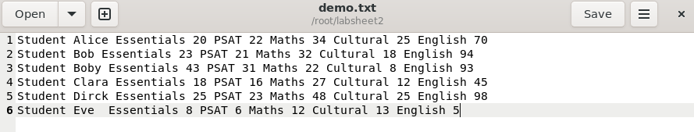

1. Find the marks obtained by Clara in all the subjects



1. Print the marks for essentials in the increasing order

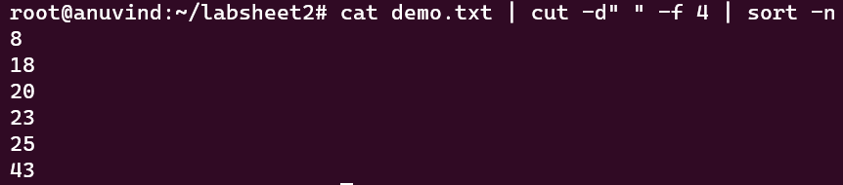

1. Find the maximum marks scored in PSAT



1. Find the minimum marks obtained in Cultural



1. Save the marks obtained by all the students in maths into a file and display it in the terminal using a single command

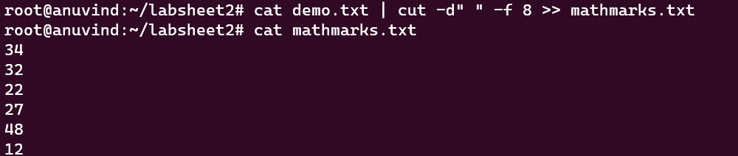

1. Print the first 3 letters of all student names.

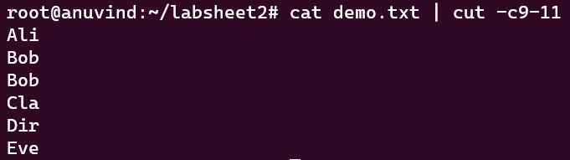

1. Print the contents of file **demo** in terminal with all alphabets in capital letters.

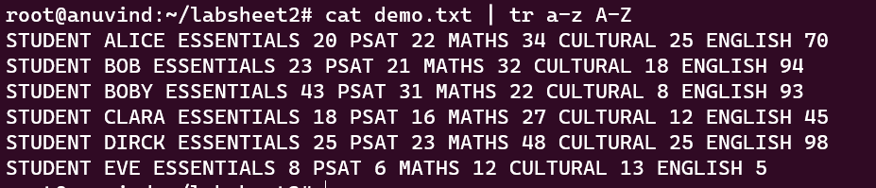

1. Print all student names after deleting the letter ‘a’

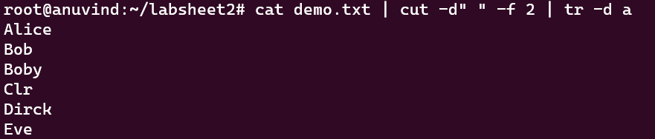

1. Count the number of lines, words and characters in demo file after removing the letter ‘S’



1. Find the number of students with their names containing the letter a, e or i



1. Find the marks of students whose names starts with ‘b’ (case insensitive)



1. Find the names of students whose names starts with ‘b’ and ends with ‘y’ (case insensitive)



Shell Programming

1. Write a shell program to perform the following actions in the given order.
   1. Create a directory hierarchy in your home folder



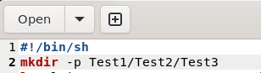

* 1. Create a file file1 in directory Test3 with the contents same as output of the command ls -l



* 1. Go to directory Test3



* 1. Find the names of all files and folders in file1



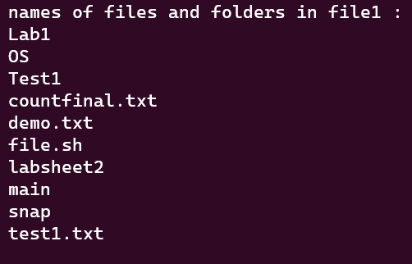

* 1. Find the names of all files and folders starting with d(case insensitive)



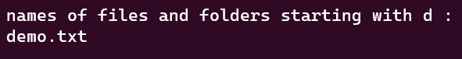

* 1. Print all words of file1 on a separate line.



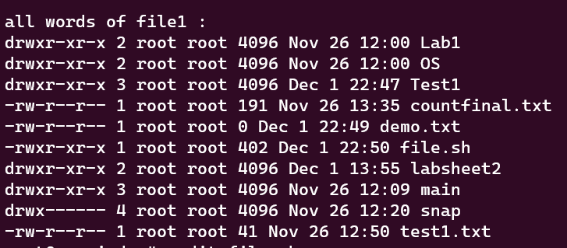

* 1. Go back to your home directory.



**Full code :**

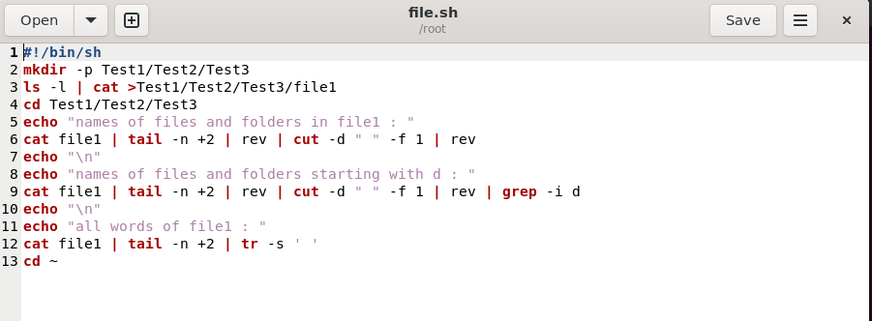

1. Write a shell program to perform the following actions in the given order.
   1. Create a file **numericdata** with the following contents

Karunagappally 34567 7864 6785

Kollam 56754 6754 7654

Vallikkavu 54328 7548 45675

Trivandrum 16423 6654 6754

Ernakulam 28796 8549 9875

Kayamkulam 35589 75892 3451

kottayam 45557 6773 6547

tirukulum 45675 56476 7896

(Hint : First field is referred as Place second as code1 third as code2 and fourth as code3)

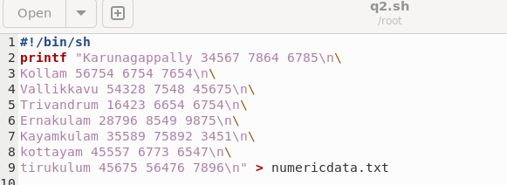

* 1. Display the details of Places that starts with ‘T’(case sensitive)

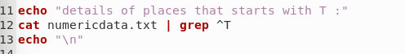

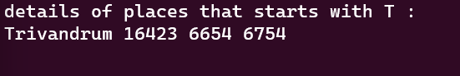

* 1. Display code3 in sorted order(ascending) of the places that start with ‘K’(case insensitive)



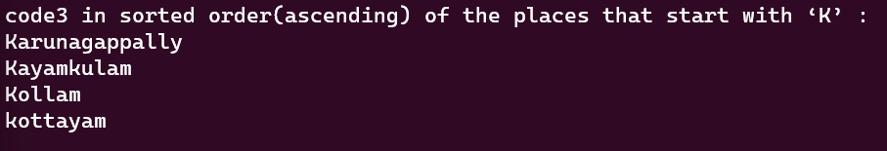

* 1. Filter code2 that starts with 6 and ends with 4

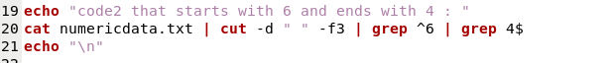

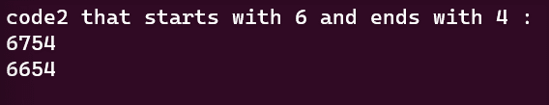

* 1. Filter code2 having one or more occurrence of the digit 6.



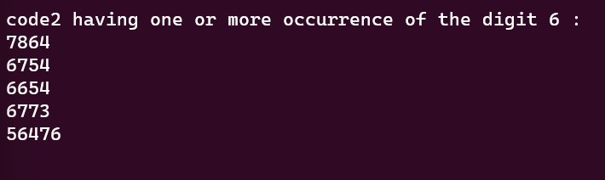

* 1. Filter all code1 having one or more occurrence of the digit 5.



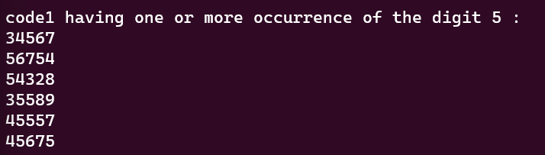

**Full code:**

